## Merchant

Demo date: April, 22, 2024  
Scoping start date: none

MSA Signature Date: May 28, 2024

Onboarding Kick Off Date: TBD  
Go Live Date: TBD

GTM POC: Jarrett  
Implementation POC:

ERP: QBO

Tax Integration: Other

### 

### Key people at Merchant

### Accountant: n/a

### CFO: Yan Ray (raise@inbeat.agency)

### Customer service rep who is really involved:

* Account Receivable POC: Reymon
* Billing POC: n/a

### etc.

### Company summary

inBeat is a performance-forward Creator Content Marketing Agency.

Goals

To automate the manual process in their AR workflow   
  
AE Notes

Any important relationship information  
  
1) What is Merchant Temperament? Very chill

2) Is there key POC the buyer/decision maker? Unsure but probable   
3) What are the Tabs features the key POC care about? Core platform

### Billing model

* Info on how merchant bills: unknown
* How contract is broken up: unknown
* One off things to know about merchant: The have multicurrency

### Billing model

* Are the unique things about the customer creation process for this merchant?
  + None

### Contract Processing Steps

1. Steps to process
   1. For description, use description within the table as well as the percentage of the cost, if specified. For example:

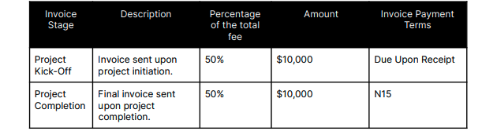

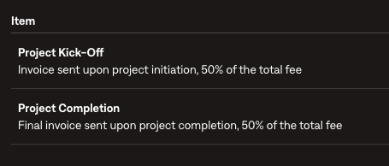

* 1. For new SOW version, you may see multiple items in a single chart (see below). Instead of description, they’ve written “Fee Breakdown” as the column header. Everything in Fee Breakdown should be its’ own billing term, and the “invoice stage” (without the parenthetical part) should be in the description along with the percentage. So for the image below (number 2) it should be as follows:
     1. BT 1
        1. Item name: Influencer Marketing Fee
        2. Item Description: Project Kick-off, 50%
        3. Price: $6000
        4. Payment Terms: Net 30
     2. BT 2
        1. Item name: Media Management Fee
        2. Item Description: Project Kick-off, 50%
        3. Price: $250
        4. Payment Terms: Net 30
     3. BT 3
        1. Item name: Media Budget
        2. Item Description: Project Kick-off, 50%
        3. Price: $1250
        4. Payment Terms: Net 30
     4. BT 4
        1. Item name: Influencer Marketing Fee
        2. Item Description: Mid-Project Checkpoint, 25%
        3. Price: $3000
        4. Payment Terms: Net 30
     5. BT 5
        1. Item name: Media Management Fee
        2. Item Description: Mid-Project Checkpoint, 25%
        3. Price: $125
        4. Payment Terms: Net 30
     6. BT 6
        1. Item name: Media Budget
        2. Item Description: Mid-Project Checkpoint, 25%
        3. Price: $625
        4. Payment Terms: Net 30
     7. BT 7
        1. Item name: Influencer Marketing Fee
        2. Item Description: Project Completion, 25%
        3. Price: $3000
        4. Payment Terms: Net 30
     8. BT 8
        1. Item name: Media Management Fee
        2. Item Description: Project Completion, 25%
        3. Price: $125
        4. Payment Terms: Net 30
     9. BT 9
        1. Item name: Media Budget
        2. Item Description: Project Completion, 25%
        3. Price: $625
        4. Payment Terms: Net 30

1. 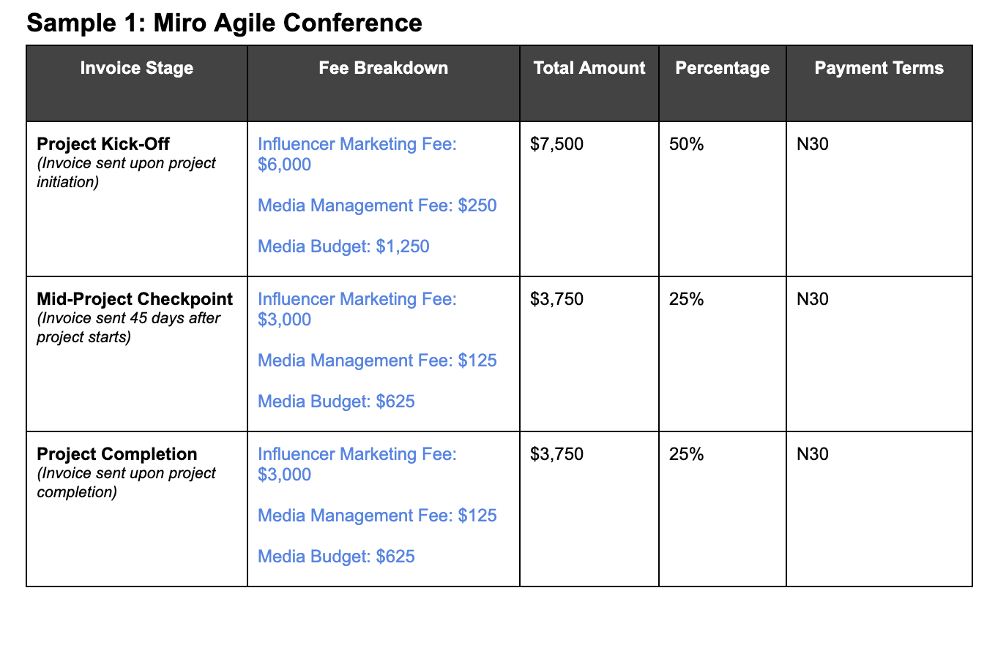
2. Anything to ignore in contracts?
   1. No
3. Specifics processing things merchant has requested that may differ by contract
   1. Milestones: Many of these contracts operate based on milestones of project deliverables.
   2. When a contract has **3 milestones** (for ex: separated into kick-off, mid-term, and competition; but not limited to this structure) follow the follow date defaults when date is *not* specified:
      1. First invoice: project start date, Net 0
      2. Mid term invoice: 45 days from project start date, Net 15
      3. Final invoice: 90 days from project start date, Net 15
   3. When a contract has **2 Milestones**
      1. First invoice: project start date
      2. Second invoice: 60 days from project start date
   4. When a contract has specified **Month #1, Month #2**, etc default to consecutive monthly terms with Net 15 (if payment terms no specified)
4. Default Service Term
   1. If None Listed, Ops Default is 1 Year
5. Default Net Payment Terms
   1. If None, Ops Default is 0
6. Default Billing Frequency
   1. If None Listed, Ops Default is Monthly
7. How do we handle taxes as a line item?
   1. Most customers are not charged sales tax, only Canada. Will tackle this after implementation is complete for the rest of their customers

### Events Processing (if necessary)

* A handful of their customers are also villages based on social media usage. All calculations are already computed, and they will be using Tabs usage function to upload the monthly $ amounts of spend per customer.
* Usage contracts will call this out in a few different ways. Look for **“Media Management Fee”.** This will exist either in a table or a paragraph, 2 examples listed below. If this is seen, process the billing term as follows:
  + Title: Media Buy Management Fee
  + Type: Unit price
  + Amount: $1
  + Integration item: Paid Media Management Fee
  + Event Type: Paid Media Spend
* Do not need to worry about:
  + Minimums, access fee/discount
  + **\*\*\*Only create the BT outlined above for usage**

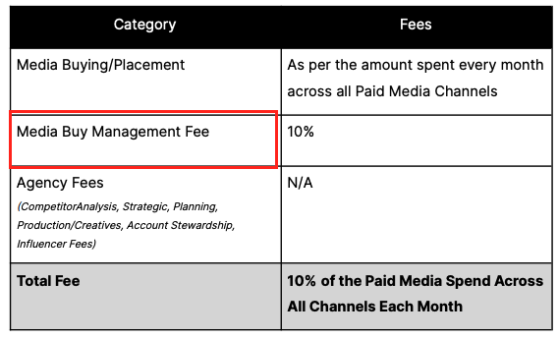

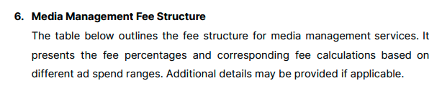

Integration Items Processing (if necessary)

* What are the instructions for assigning integration items?
  + Integration item will equal the Service Type that is identified in the contract. If not included in this, leave blank and they will update it themselves.

| **Service Type** | **Integration Details** |
| --- | --- |
| Influencer Marketing Spark Ads (Organic Posting + Whitelisting) | Influencer Marketing |
| Influencer Marketing | Influencer Marketing |
| User-Generated Content (Just Content) | Influencer Generated Content |
| Paid Media | Paid Media Management Fee |
| UGC Only | Influencer Generated Content |
| SEO Services | Link Building |

Post Processing Communications (if necessary)

* Does Ops Team need to notify anyone on the team re: completion of processing batches in Implementation or Active phase?
* Who needs to be notified and when?

### Customer Information

* Any important information on specifics customers of this merchant

### Feature Requests

### Rewatch Calls

* Rewatch by dates